 | nnnnnnnnnnnnnnnnnnnnnnnnnnnnnnnnnnnnnnn  CLUB RACING  ENTRY FORM  Season 202_  Statement of Yacht & Competitor info  Declaration of insurance cover | 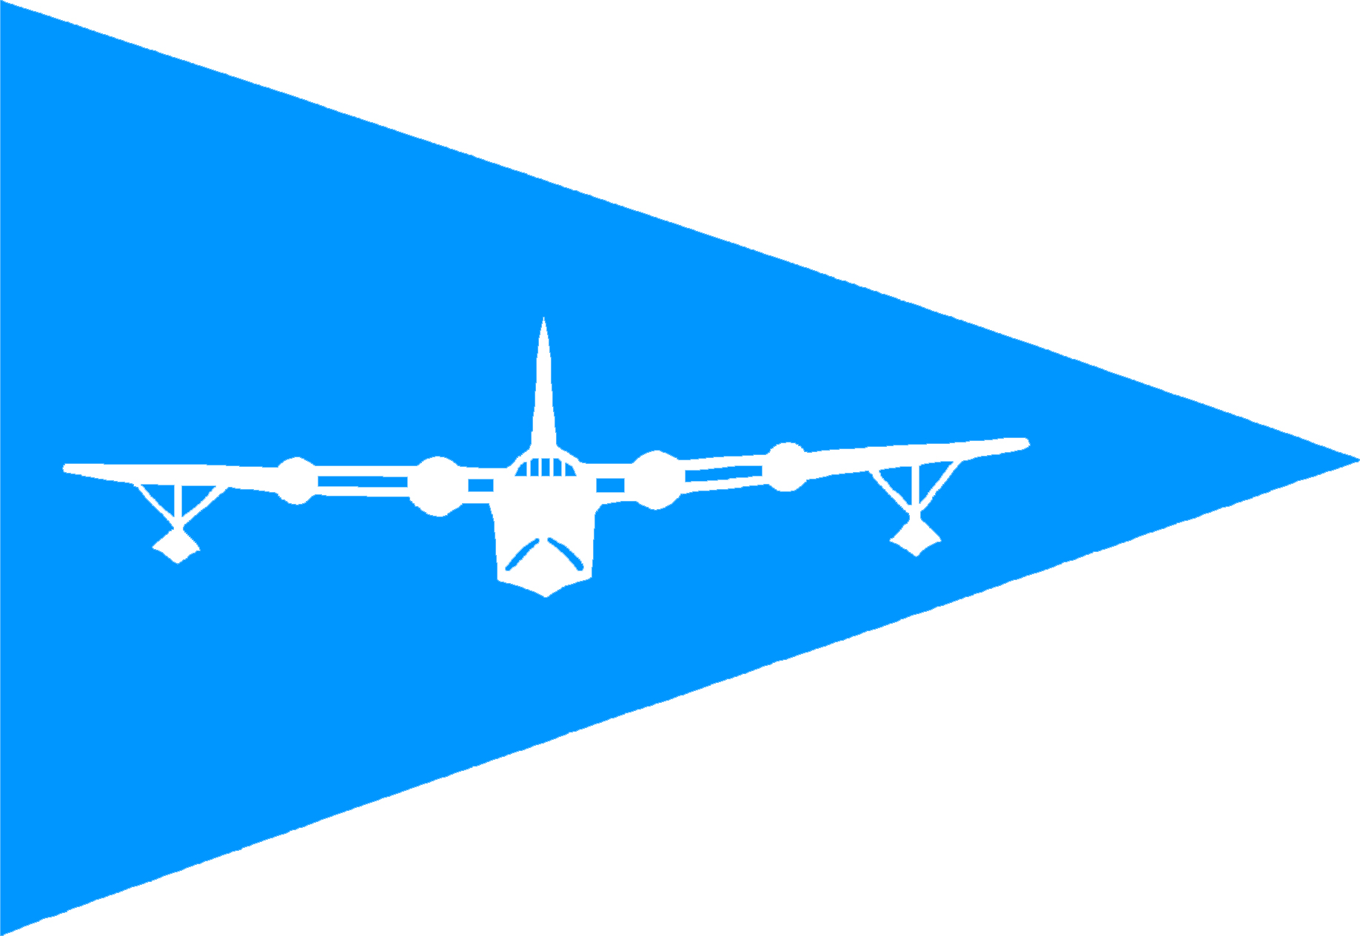
Neyland Yacht Club Pembroke Haven Yacht Club

EVENT (State universal all-season entry or individual Race, or Series) | All season Series
BOAT NAME
BOAT TYPE
Byron James NUMBER (base/no spinnaker)
SAIL NUMBER
HULL COLOUR
NAME
ADDRESS
CLUB
PHONE NUMBER /MOBILE NUMBER
EMAIL
Name of Insurance Company:
Policy No:
Start Date/End Date

INSURANCE & LIABILITY
I understand that it is the competitor’s sole responsibility whether or not to start, or to continue in, any race.
The Clubs accept no responsibility or liability for loss of life or injury to members, or others, or for the loss of or damage to, any vessel.
I confirm that this boat is insured for racing against a third party liability of at least £2 million.
I the under signed here by give Pembroke Haven Yacht Club and Neyland Yacht Club the right to check with my insurance company, that the details I have supplied are correct. I will also update the club(s) of any changes in this information.

SIGNED (Owner/Entrant)…………………………………………DATE :
Please submit this form to Club Racing officer/Race Deck
__________________________________________________________________________
FOR COMMITTEE USE ONLY
ENTRANCE FEE PAID (If applicable) | nnnnnnnnnnnnnnnnnnnnnnnnnnn
ENTERED INTO SAILWAVE
VALID BJ NUMBER
PROOF OF CORRECT INSURANCE COVER

